**Local non-linear constraints or linear constraints**

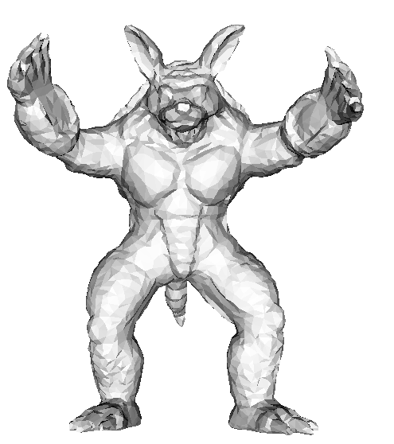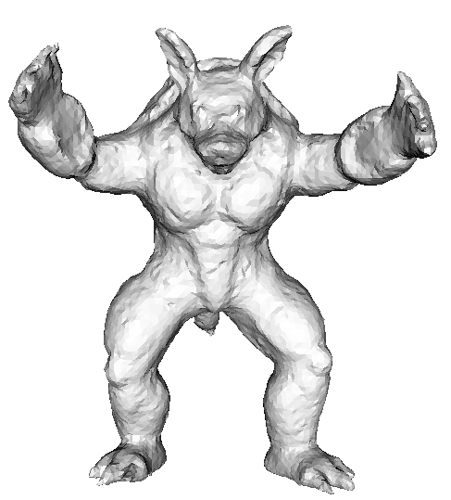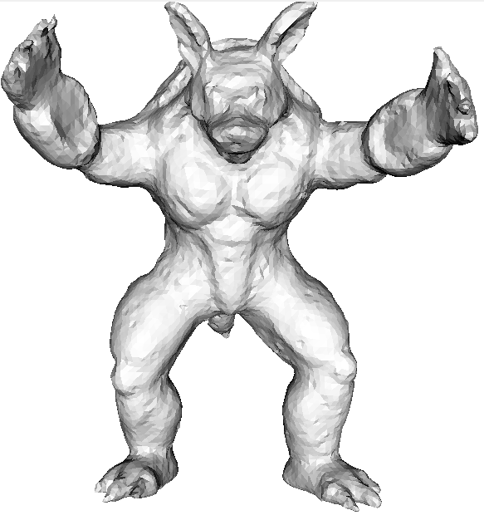

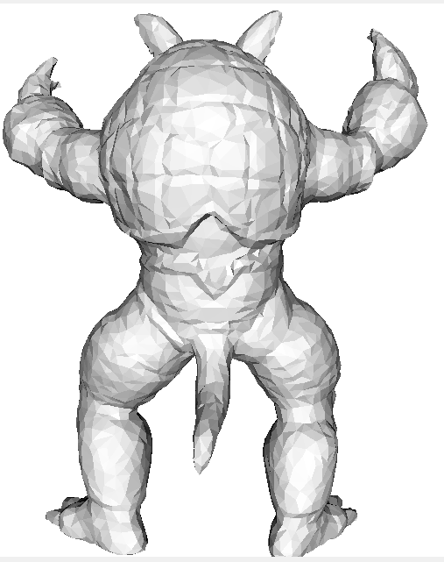 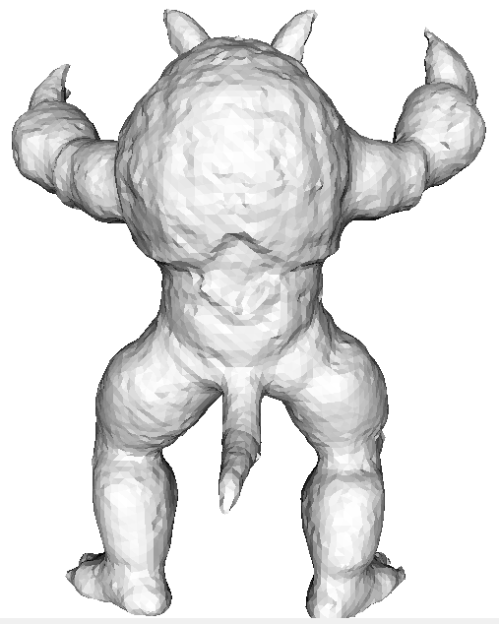 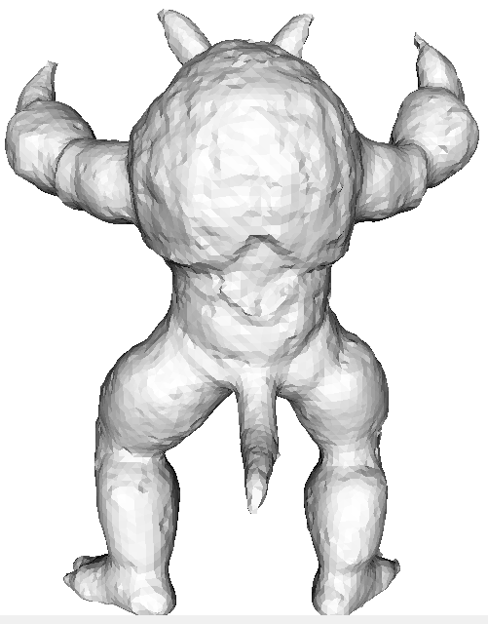

**Original mesh Local non-linear constraints Local linear constraints**

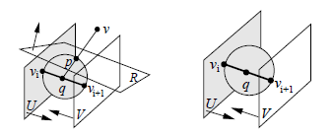

**Feasible region:**

**Linear constraints**: The intersection of three planes shown in the left of the above figure.

**Non-linear constraints**: The intersection of two planes and the outside of a sphere shown in the right of the above figure.

**Evaluation**: Enlarge the feasible region from linear constraints to the non-linear constraints cannot improve the final results.

**1. Time**

**Linear constraints**: average 0.04s for each vertex

**Non-linear constraints**: average 0.07s for each vertex

**2. Minimized energy at the solutions**



We give statistics of the energies at the solutions of linear constraints and non-linear constraints for 1000 vertices, only at 292 vertices the non-linear constraints outperform than linear ones. And the mean of the energies are:

**Linear constraints**: **1.537377976513757e-05**

**Non-linear constraints**: **1.400512852788669e-05**

**3. Closest distances from the result mesh to the original mesh**

**Linear constraints**: min : 0.000000 **max 0.009392** **mean : 0.001154**

**Non-linear constraints**: min : 0.000000 **max 0.009006 mean : 0.001161**

**Conclusion: (Feasible region VS. Minimized energy)**

**1. Enlarge the feasible region from linear constraints to the non-linear constraints cannot improve the final results.**

**2. The model of minimized energy is the key of the final result, we should try to improve the minimized energy.**

**3. Future directions**

**(1) First smooth the non-obtuse mesh, and then deform to fit.**

**(2) Using the vertices of the original mesh to move part vertices of the non-obtuse mesh.**